Chen et al., 2019

* Built a comprehensive numerical model using OpenGeoSys (OGS) by applying the dual-continuum approach integrating heat pump efficiency change.
* model verified against analytical solution Beier et al. (2014) & comparing with integrated heat flux distribution (heat flux variation over depth calculated and analyzed)
* A series of modeling scenarios designed and simulated to analyze the DBHE system performance depending on pipe materials, grout thermal conductivity, geothermal gradient, soil thermal conductivity, and groundwater flow.
* soil thermal conductivity is the most important parameter for the DBHE system performance. Both thermally enhanced grout and the thermally insulated inner pipe elevate BHE outflow temperature. With a geothermal gradient of 0.04 °C /m, the short-term sustainable specific heat extraction rate imposed on the DBHE can be increased to 150–200 W/m.
* The long-term scenarios of 30 years were simulated to clarify the sustainability of such system based on the quantification of temperature evolution and temperature recovery ratio every year. With a standard geothermal gradient of 0.03 °C m−1, the extraction rate has to be kept below 125 W m−1 in the long-term operation.
* Assessment of the efficiency of operating such system by the coefficient of system performance (CSP): found that the lower limit of the DBHE system is at a CSP value of 3.7.

BHE principle: As the surrounding soil and rock are hotter than the DBHE outer surface, circulating fluid is normally injected through the annulus part downwards and returned from the inner pipe, so that the heat exchange between soil and outer pipe is enhanced and the heat loss from the inner pipe can be minimized (Cai et al. 2018; Holmberg et al. 2016).

Literature review: study of the impact of thermal properties around and inside the standard BHE investigated by multiple researchers through lab and field experiments:

* Acuña and Palm (2013): results from 3 DTRT carried out on two coaxial pipe-in-pipe BHEs at different flow rates.
* Wagner et al. (2014) concluded that advection-influenced DTRT could potentially be used to determine integral hydraulic conductivity of the subsurface.
* Soldo et al. (2016) measured the carrier fluid temperature along the BHE using a fiber optic cable placed inside the BHE pipes that are located in the city of Osijek.
* Beier and Holloway (2015), Lhendup et al. (2014) evaluated the DBHE thermal performance and highlighted the importance of thermal conductivity of the inner pipe, as well as the discharge rate of fluid carrier.
* Galgaro et al. (2015) analyzed the system located in north-east Italy with respect to its thermal impact on underground and groundwater temperature.
* Dijkshoorn et al. (2013) evaluated the feasibility of an installation of coaxial deep BHE for space heating and cooling the building of the university in Aachen, Germany. After 20-years of operation, DBHE outflow temperature too low to drive the adsorption unit for cooling.

Sustainability analysis and temperature prediction of DBHE are conducted either by analytical, semi-analytical solutions (i.e. Li and Lai 2015, Gordon et al. (2017) and Rivera et al. (2016). Ranges from line source models to transient heat transfer models) or numerical simulations.

* principle and performance of the BHE system investigated based on single or a few parameters, while sustainability and efficiency analysis difficult to perform due to high computational demand.

Here: apply dual-continuum approach (Al-Khoury et al. 2010; Diersch et al. 2011a; Diersch 2013):

* soil compartment is discretized with 3D prism elements
* DBHEs are represented by 1D elements

Heat transport governing equations in the soil and within the DBHE are assembled into one global linear equation (no need to fully discretize every component)

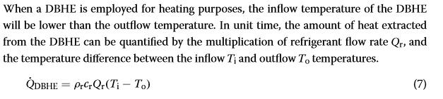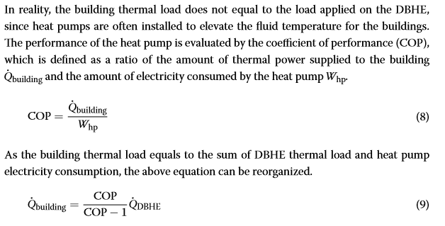

Results:

* a higher thermal conductivity value will lead to a faster recovery in the outflow temperature. By comparing the soil thermal conductivity of 2.0 W m−1 K−1 (scenario #4A) and 3.0 W m−1 K−1 (scenario #4E), there will be an outflow temperature difference of 0.89 °C at the end of the recovery period.
* extracted thermal energy via the DBHE is mainly from the bottom part of the soil (see heat flux analysis). Deep aquifers have higher temperature and provide extra thermal energy through groundwater advection. But heat energy supplied by deep aquifers only accounts for a tiny ratio of total amount of extracted energy. And such extra energy supplied by deep aquifers will be distributed along the depth of the DBHE during the circulating fluid flowing process so that the outflow temperature of the DBHE will not be changed much. All in all, since the overall depth of the aquifer in the investigated scenarios is still a small portion of the DBHE length, the amount of thermal energy recharged (deep aquifers) or discharged (shallow aquifers) through the groundwater advection takes only a small part in the overall extracted heat from the deep subsurface. This feature is largely due to the extended length of the DBHE, which is different from shallow BHEs.
* stabilized outflow temperature profile suggests that heat extraction and recovery in the subsurface has reached equilibrium after 20 years with extraction rate 100 W/m.
* Taking advantage of the simulated inflow and outflow temperature, the temperature recovery ratio of every year was also calculated and its evolution is plotted in Fig. 12 for analysis, along with the statistical distribution of CSP values over 30 years of operation. It can be found that the temperature recovery ratio is lower than 99.5% in the first 5 years, and gradually increases afterwards. After 30 years, this ratio stabilizes at 99.91% and 99.89% for the 100 W m−1 and 125 W m−1, respectively. The variation range of recovery ratio is within 0.03% in the last ten recovery seasons and it approaches 100% in both long-term scenarios, indicating that the heat energy extracted during heating season is nearly fully recovered. It can be also calculated that over 30 years’ operation, the average CSP with 100 W m−1 specific heat extraction rate will be 0.24 higher than that in the 125 W m−1 case.